**MINI-PROJECT**

**(2020-2021)**

**IOT ENABLED ROBOTIC CAR**

**PROJECT REPORT**

**Department of Computer Engineering & Applications**

**Institute of Engineering & Technology**



**SUBMITTED TO: SUBMITTED BY:**

Mr. Ajitesh Kumar Satyam Singh(171500296)

Tej Pratap Singh()

|  |
| --- |
| **TABLE OF CONTENTS** |
| **Certificate …………………………………………………………………….**  **Synopsis……………………………………………………………………….**  **Acknowledgement……………………..…………………………………….**  **Abstract………………………………………………………………………** |
| **1. Introduction….…………………………………………………………….** |
| 1.1 Overview……………..………………………………………………… |
| 1.2 Motivation…………………………………………………………….... |
| 1.3 Problem Statement….………………………………………………….. |
| 1.4 Objective……………………………………………………………….. |
| **2. Software Requirement Analysis…………………………………………..** |
| 2.1 System Analysis………………………………………………………... |
| 2.2 Role of System Analyst……………………….……………………….. |
| 2.2.1 Main roles of System Analyst…………………………………..….. |
| 2.3 Users……………………………………………………………….…... |
| 2.4 Methodology…………………………………………………………...  2.5 Dependencies /External Systems……………………………………....  2.6 DFD………………………………………………………………........  2.7 Use-case Diagram…………………………………………………..….. |
| **3. Implementation details ………………………………..………………...**  **4. Contribution Summary………………………………………………….**  **5. Tables……………………………………………………………………..** |

|  |
| --- |
| **6.Project Work………………………………………………………………**  **7.Future Scope………………………………………………………………** |
| **Reference………………………………………………………………….** |

**Certificate**

This is to certify that Satyam Singh and Tej Pratap Singh of B.Tech (CSE) 3rd year has successfully completed the **MINI PROJECT** named **IOT Enabled Robotic Car** Development under the Guidance of **Mr. Ajitesh Kumar**

During 2020-21

Signature:

**Mr. Ajitesh Kumar**

**PROJECT TITLE-** iot Enabled Robotic Car

**HARDWARE REQUIREMENT-** Node MCU, L298N Motor Driver, Motor 4, Battery 12 Volt

**SOFTWARE REQUIREMENT** - Blynk App

**ACKNOWLEDGEMENT**

I have taken efforts in this project. However, it would have not been possible without the kind support and help of many individuals. On the completion of this project I would like to extend my sincere thanks to all of them.

I am highly indebted to this project guide Mr. Ajitesh Kumar sir for their guidance and constant supervision as well as of for providing necessary information regarding the project.

I wish to extend my sincere gratitude to Prof. Anand Singh Jalal, Head of Department of Computer Engineering and Applications and faculty of CEA Department of Computer Engineering and Application and faculty of CEA Department of GLA University for their guidance, encouragement and give this opportunity and valuable suggestion which prove extremely useful and helpful in completion of this synopsis.

I would also like to thank all those who directly or indirectly supported or helped me. I would like to express my gratitude towards my parents and member of my college for their kind cooperation and encouragement which helped me in completion of this project.

All of them have willingly helped me out with their

abilities.

**INTRODUCTION**

Internet of Things (IOT) is a new revolution of the Internet. It enable to connect remote and mobile things or machines or assets through the use of wireless communications and low-cost sensors, computing and storage devices.

This project shows how to use Internet of Things (IOT) for controlling Robotic car remotely (anywhere), provided that your robot is connected to the Internet.

**USES OF THIS PROJECT**

The Internet is now advancing from a network of computers to a network of things**.** IOT has huge application area such as traffic monitoring, smart homes, smart parking management, vehicle tracking system and other industrial applications etc. Robotic car is used to achieve high degree of precise path control from the user side to achieve standard operations like moving at a particular target location, collecting data and avoiding any obstacle to prevent collision

**OVERVIEW**

The overall framework should contain a user, an Android smartphone field, an Arduinobased car with assistance of the Arduino integrated development environment (IDE) in the PC, sketches are compiled and uploaded into the Arduino board via a USB transmission line .The car and mobile phone are linked via wireless communication. By touching or pressing on the screen of an Android phone, a manipulator can send commands to the Arduino microcontroller on the car through WiFi and observe the corresponding executions accomplished by actuators, for example motors. Two gear motors, two wheels, a battery holder, batteries, a switch and a baseboard compose the chassis of the car. Uncomplicated operations and compact user interfaces are preferred. Initially the commands include: move forward, move backward, turn left, turn right, rotate left, rotate right, activate obstacle detection, and deactivate obstacle detection. These commands can be given via user application. It is possible to locate the car continuously in the UI and get the feedback and data regarding to the car .There is a provision of feedback signals to the controlling device like mobile in which the graphical control interface is installed thus avoiding collision and changing of path is very easy in our design.

**EXISTING SYSTEM-**

The proposed system will have the following components:

1-ESP8266 (Node MCU)

2-L298N Motor Drive Module

3-Arduino UNO

4-Robot Chassis

5-4 \* 5V Geared Motor

6-Connecting Wires

7-Power Supply (or battery)

ROLE OF HARDWARE-

**1-ESP8266 (Node MCU)-**

NodeMCU is an open-source Lua based firmware and **development board** specially targeted for IoT based Applications. It includes firmware that runs on the ESP8266 Wi-Fi SoC from Espressif Systems, and hardware which is based on the ESP-12 module.

**NodeMCU Development Board Pinout Configuration**

|  |  |  |
| --- | --- | --- |
| **Pin Category** | **Name** | **Description** |
| Power | Micro-USB, 3.3V, GND, Vin | **Micro-USB:** NodeMCU can be powered through the USB port    **3.3V:** Regulated 3.3V can be supplied to this pin to power the board    **GND:** Ground pins    **Vin:**External Power Supply |
| Control Pins | **EN, RST** | The pin and the button resets the microcontroller |
| Analog Pin | A0 | Used to measure analog voltage in the range of 0-3.3V |
| GPIO Pins | GPIO1 to GPIO16 | NodeMCU has 16 general purpose input-output pins on its board |
| SPI Pins | SD1, CMD, SD0, CLK | NodeMCU has four pins available for SPI communication. |
| UART Pins | TXD0, RXD0, TXD2, RXD2 | NodeMCU has two UART interfaces, UART0 (RXD0 & TXD0) and UART1 (RXD1 & TXD1). UART1 is used to upload the firmware/program. |
| I2C Pins |  | NodeMCU has I2C functionality support but due to the internal functionality of these pins, you have to find which pin is I2C. |

**NodeMCU ESP8266 Specifications & Features**

* Microcontroller: Tensilica 32-bit RISC CPU Xtensa LX106
* Operating Voltage: 3.3V
* Input Voltage: 7-12V
* Digital I/O Pins (DIO): 16
* Analog Input Pins (ADC): 1
* UARTs: 1
* SPIs: 1
* I2Cs: 1
* Flash Memory: 4 MB
* SRAM: 64 KB
* Clock Speed: 80 MHz
* USB-TTL based on CP2102 is included onboard, Enabling Plug n Play
* PCB Antenna
* Small Sized module to fit smartly inside your IoT projects

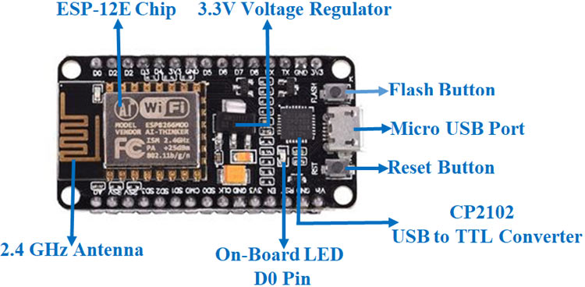

**L298N Motor Drive Module-**

This **L298N Motor Driver Module** is a high power motor driver module for driving DC and Stepper Motors. This module consists of an L298 motor driver IC and a 78M05 5V regulator. **L298N Module** can control up to 4 DC motors, or 2 DC motors with directional and speed control.

**L298N Module Pin Configuration:**

|  |  |
| --- | --- |
| **Pin Name** | **Description** |
| IN1 & IN2 | Motor A input pins. Used to control the spinning direction of Motor A |
| IN3 & IN4 | Motor B input pins. Used to control the spinning direction of Motor B |
| ENA | Enables PWM signal for Motor A |
| ENB | Enables PWM signal for Motor B |
| OUT1 & OUT2 | Output pins of Motor A |
| OUT3 & OUT4 | Output pins of Motor B |
| 12V | 12V input from DC power Source |
| 5V | Supplies power for the switching logic circuitry inside L298N IC |
| GND | Ground pin |

**L298 Module Features & Specifications:**

* Driver Model: L298N 2A
* Driver Chip: Double H Bridge L298N
* Motor Supply Voltage (Maximum): 46V
* Motor Supply Current (Maximum): 2A
* Logic Voltage: 5V
* Driver Voltage: 5-35V
* Driver Current:2A
* Logical Current:0-36mA
* Maximum Power (W): 25W
* Current Sense for each motor
* Heatsink for better performance
* Power-On LED indicator

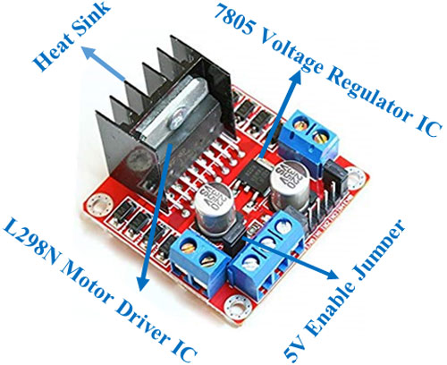

**WORKING**

**1 - Sending command**-The mode of sending command to the car is by manually clicking buttons visible in the user interface which is the android application developed in the android studio with buttons controlling movements like move forward and backward, turn right and left, stop,pick and drop.

**2 - Checks for command validation**- On successful decoding the dedicated event handlers take care of the rest of the task. But on unsuccessful decoding the client is requested to generate any command from the set of valid commands. This request is in actual a message displayed on the user interface of the application.

**3. Stores commands in a cloud service**- Queue provides a well-defined and flexible service to this system. As both car information and commands are needed to be transferred at the desired places or devices and at the same time, so two queues were used- one for data and another for command. The arduino in the car listens to the Command Queue and it sends data to the Data Queue. On the other hand the android application in the controller end listens to the Data Queue and it sends command to the Command Queue.

**4 - Processor (Mobile) collects the command and passes to theArduino**- There are basically four modes of command signals that the Arduino receives from the processor. These are:

A- Move according to the command signals sent by the user,

B-pick and drop any object,

C-To send GPS sensor values acquiredfrom the GPS,

D-To send the data received from the obstacle detector.

**5 - Arduino takes action according to the command**- Based on the command received Arduino takes appropriate action. For example: acquiring GPS sensor value, acquiring obstacle sensor reading and changing the car’s direction of motion or state.The GPS sensor continuously pings for getting the actual location of the car. Arduino also pings the IR obstacle sensor for distance of obstacle before the car. Based on the commands, Arduino changes the direction and speed of the motors using the motor controllers.

**6 - Updates GPS position of the car-**Whenever the Robotic Car is commanded to change its position, Arduino polls the GPS sensor to get the updated GPS position and then when it is commanded to send the GPS position then this location is sent to the Data queue of the cloud service bus. This data is later received by the android application which updates the UI accordingly.

**7 - Surveillance camera provides visual track of the robotic car**- the robotic car here is equipped with a surveillance camera which enables the user to be aware of the motion of the car and the environment in which the car is being operated.

**LEFT MOTORS RIGHT MOTORSOUTCOME**

Forward ForwardForward

Forward Static Left

Static Forward Right

Backward BackwardBackward

**FUTURE SCOPE**

In this paper an efficient control system of a robotic car is incorporated with IOT. The cloud service helps the system to reduce memory load. Stored messages are automatically removed after a certain amount of time. The performance results prove that if the incorporation is efficient. The wireless range is too small. It can be efficient if GPRS, module is used for wireless medium. Including object detection method is one of the main future works that needs to be implemented.

**Arduino UNO –**

The **Arduino Uno** is one kind of microcontroller board based on ATmega328, and Uno is an Italian term which means one. Arduino Uno is named for marking the upcoming release of microcontroller board namely **Arduino Uno Board 1.0**. This board includes digital I/O pins-14, a power jack, analog i/ps-6, ceramic resonator-A16 MHz, a USB connection, an RST button, and an ICSP header. All these can support **the microcontroller** for further operation by connecting this board to the computer. The power supply of this board can be done with the help of an AC to DC adapter, a USB cable, otherwise a battery. This article discusses what is an **[Arduino Uno microcontroller](https://www.elprocus.com/what-is-arduino-uno-r3-pin-diagram-specification-and-applications/" \t "_blank)**, pin configuration, **Arduino Uno specifications or features**, and applications.

**Features of Arduino Uno Board**

The **features of Arduino Uno ATmega328** includes the following.

* The operating voltage is 5V
* The recommended input voltage will range from 7v to 12V
* The input voltage ranges from 6v to 20V
* Digital input/output pins are 14
* Analog i/p pins are 6
* DC Current for each input/output pin is 40 mA
* DC Current for 3.3V Pin is 50 mA
* Flash Memory is 32 KB
* SRAM is 2 KB
* EEPROM is 1 KB
* CLK Speed is 16 MHz

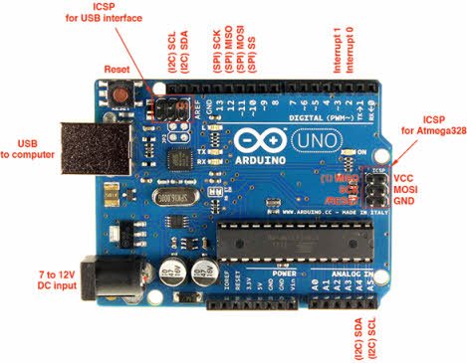

**Robot Chassis-**

**Chassis** comprise the body of a **robot**. Roll cages, bumpers and other body accessories can also be found in this category.

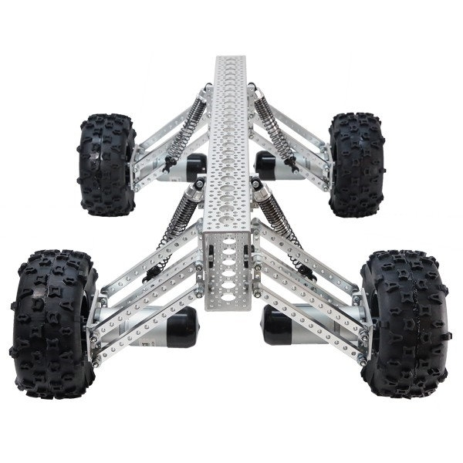

**4 \* 5V Geared Motor-**

A 4\*5v geared DC Motor has a gear assembly attached to the motor. The speed of motor is counted in terms of rotations of the shaft per minute and is termed as RPM .The gear assembly helps in increasing the torque and reducing the speed. Using the correct combination of gears in a gear motor, its speed can be reduced to any desirable figure. This concept where gears reduce the speed of the vehicle but increase its torque is known as gear reduction.

**Description:**  
  
**DC 5V 2 Phase 4 Wire Miniature Stepper Gear Box Motor**  
**Specification:**  
  
Model: GM1527-10  
Voltage: 5.0V  
ReductionRatio: 1 : 10  
NO.of Phases: 2 Phases  
Excitation Method: Bipolar 2-2 Phase  
Step Angle: 1.8° +/- 7%  
Rotation Direction: CW/CCW  
Detent Torque: 50gf.cm (Ref)  
Resistance Per Phase: 30Ω +/- 7%  
Holding Torque: 50gf.cm min  
Pull Out Torque: 40gf.cm min  
Max No Load Response: 1000HZ Min  
Max Slew Speed: 800HZ Min

